**BAHRIA UNIVERSITY (KARACHI CAMPUS**)

**Pakistan Studies & Global Perspective (Pak- 103)**

**Assignment 02**

**Fall 2023**

**Class: BSE 3B Shift: Morning**

**Course Instructor: Ms RANI KIRAN Due Date: 27 Oct 2023**

**Assignment Date: 18 Oct 2023 Marks: 05 Points**

**Student Name: ABDULLAH Registration #: 81962**

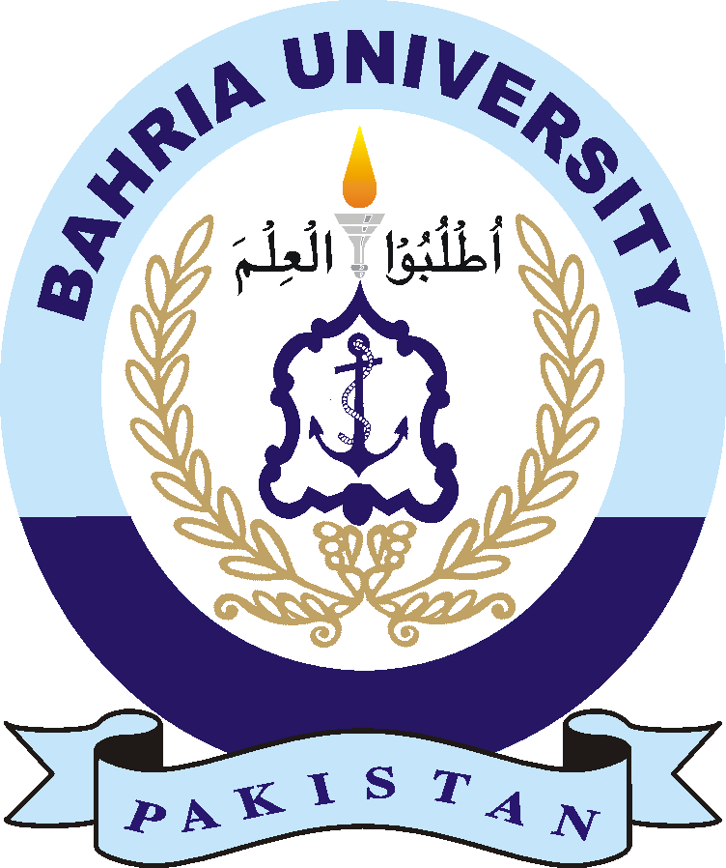

Question:

Choose any one tourist destination of Pakistan from following:

Murree, Bhurban, Galiyat, Multan, Naran, Skardu, Gilgit-Baltistan, Kalash Valley, Taxila, Gwader, Turbat, Mardan, Hunza, Karachi, Islamabad, Hyderabad, Quetta, Peshawar, Bahawalpur, Ayubia, Thatta, Kashmir point, Larkana, Sukkur, Jhelum, Sialkot, Abbottabad, Chitral, Rawalpindi, Sahiwal, Sargodha, Sawat, and Lahore.

Explain:

* Why this city is famous?
* Understand the Historical, Geographical recreational and Economic potential aspects of the site.
* What are the features that attract this city?
* In the last how we can improve and promote tourism in Pakistan.
* Include pictures.

Use reliable sources for reference.